# Users Guide to File Explorer Application

## Overview:

The File Explorer Application allows users to interact directly with the underlying operating system. The File Explorer Application leverage’s the operating system’s file system. Users are able to run four file system processes: (1) Make a copy of a root directory and output the copied directory to a new directory location; (2) Move a root directory to an already existing directory location; (3) Search an existing directory location for all instances of a file name; (4) Locate all instances of a file name in an existing directory and consolidate all instances of those files into a single file;

# File Explorer Application Users Instruction Manual

Please read the instruction manual before launching the File Explorer Application.

Note the File Explorer Application has technical requirements and all requirements must be downloaded in order for users to utilize the File Explorer Application. Please ensure your machine has the following programs downloaded:

* Python 3.5
* PyQT5

## Getting Started: Launching the File Explorer Application

Step 1: In the source code folder launch file name: ‘**mainwindow_fsat’** in the command window or a Python IDE

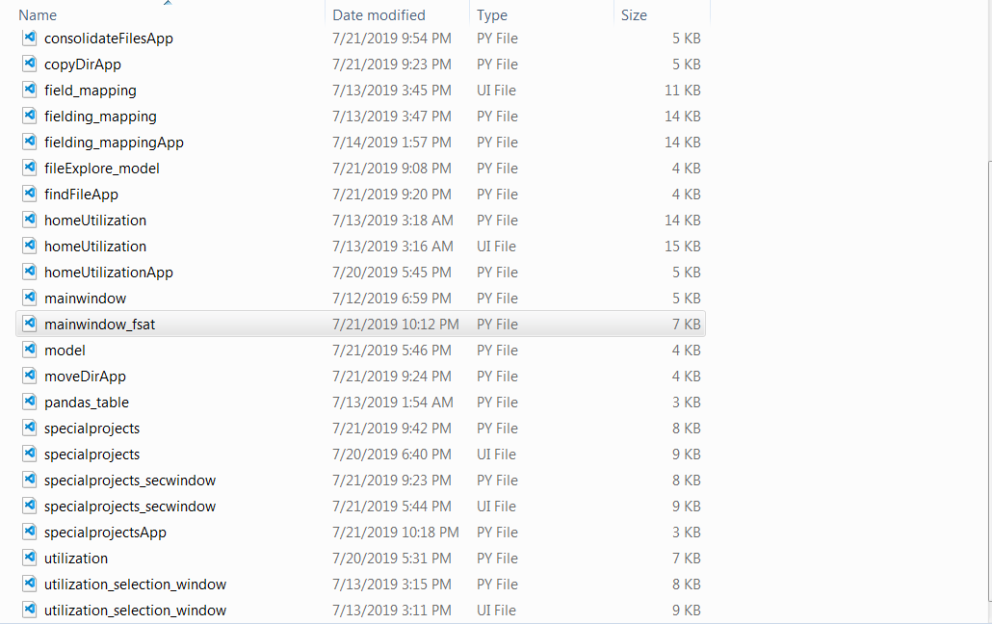

Step 2: Once the File Explorer Application has been successfully launched, the main window will pop-up. Select ‘Special Projects’ and click ‘Start Study’.

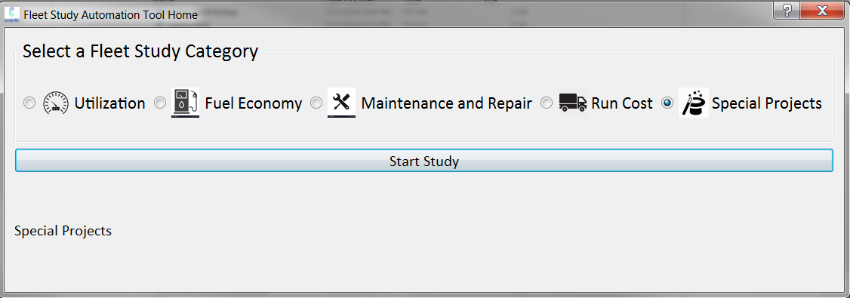

Step 3: Once step 2 is successfully executed, The Special Projects Main Window will appear.

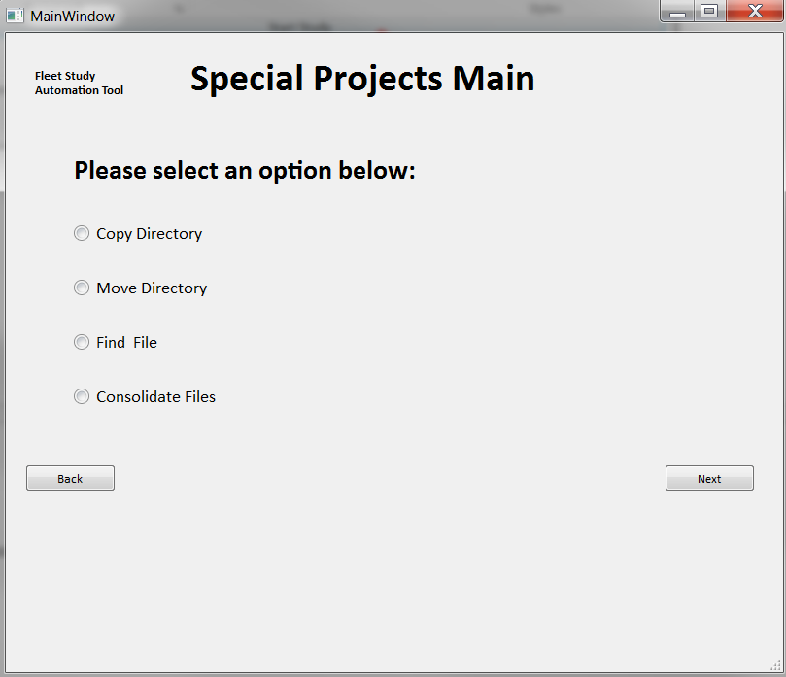

Choose a selection and click ‘next’. Steps 4a – 4d walks the user through how to launch and run each of the four processes: (1) Copy Directory, (2) Move Directory, (3) Find File, and (4) Consolidate Files

## Step 4a: Copy Directory

The Copy Directory allows users to make a copy of a root directory and output the copied directory to a new directory location. **Please note the field: ‘Target Directory/Folder’ must have a unique directory name that does not already exist.**

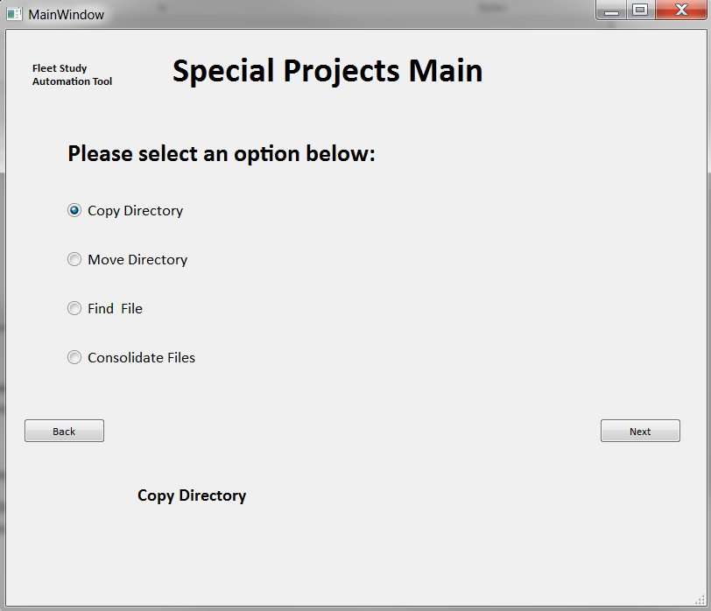

First, pass in the Root Directory to be copied by clicking the ‘browse’ button or type in the full path.

Next, pass in a unique Target Directory/Folder name and then click ‘Execute’

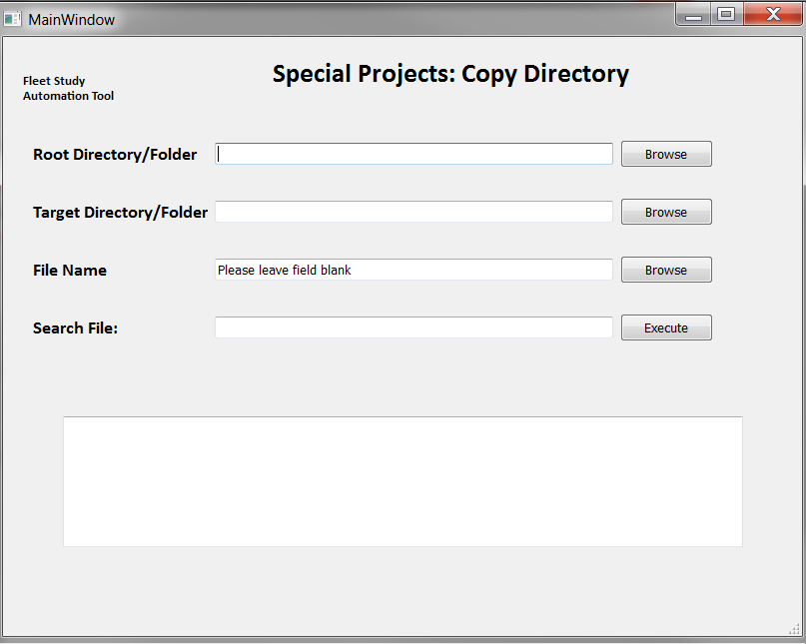

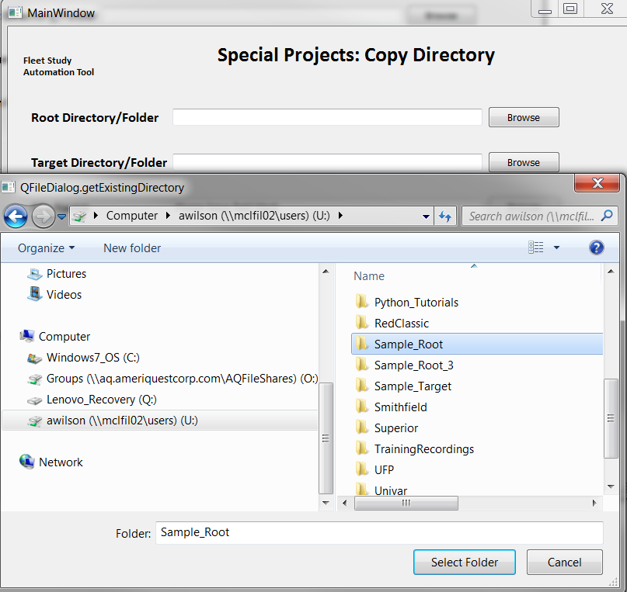

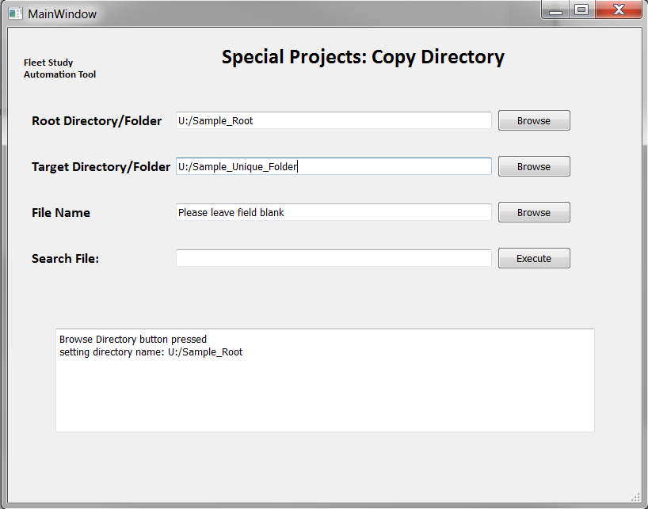

Users will immediately receive processing feedback in the command window

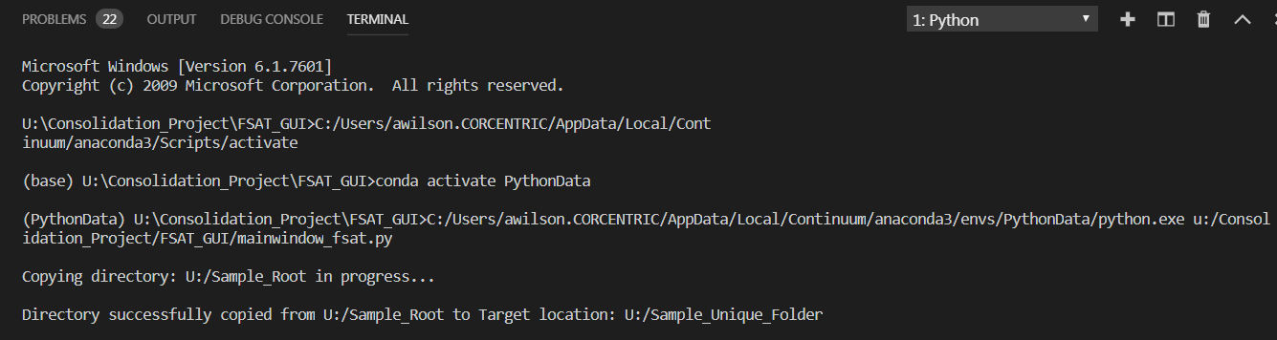

Users will also receive feedback in the File Explorer Application (expect a slight delay in feedback)

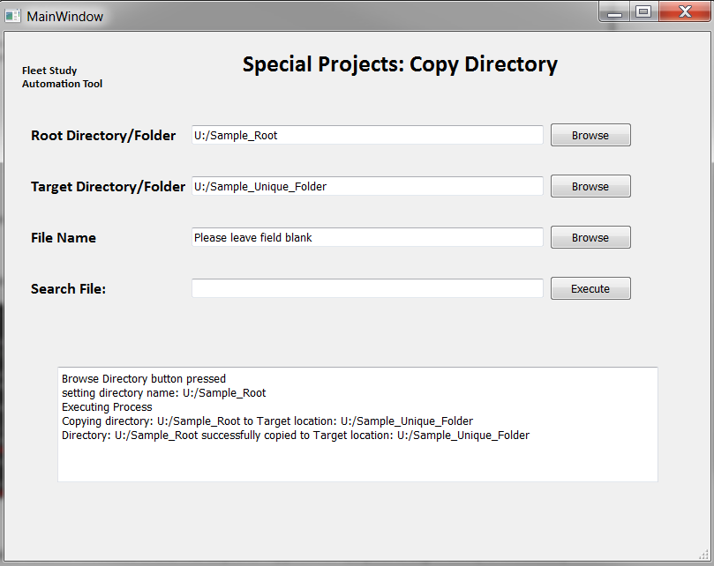

Lastly, open the Target Directory/Folder Location and users will see the directory has been copied successfully. Close window.

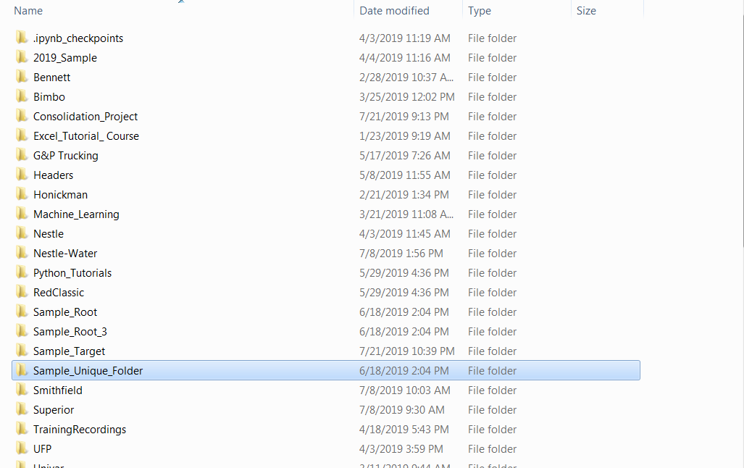

## Step 4b: Move Directory

The Move Directory allows users to move a root directory to an already existing directory location.

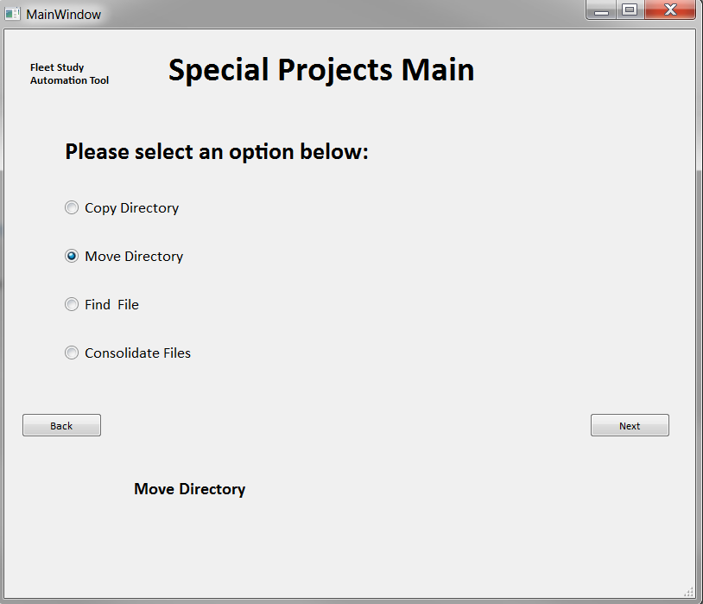

First, pass in the Root Directory to be moved by clicking the ‘browse’ button or type in the full path.

Next, pass in the Target Directory where file will be moved by clicking the ‘browse’ button or type in the full path. Lastly, click ‘Execute’.

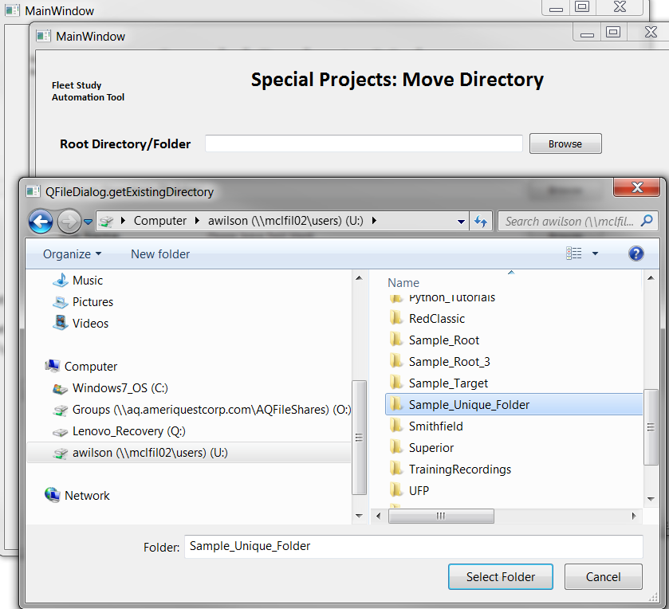

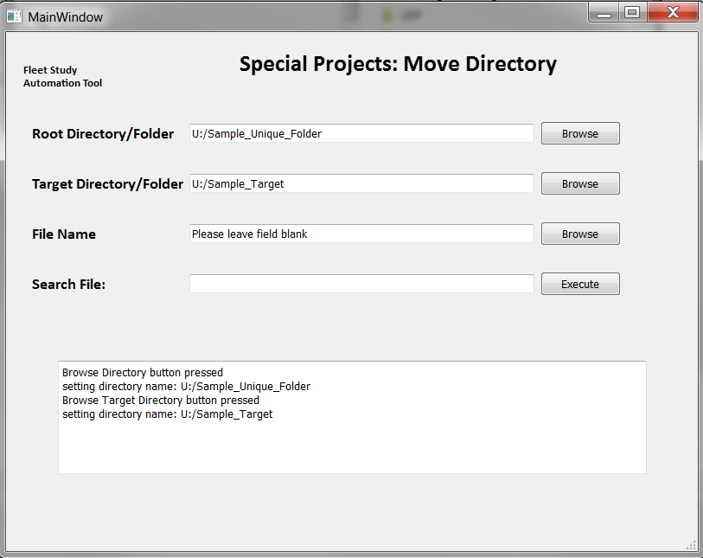

Users will immediately receive processing feedback in the command window

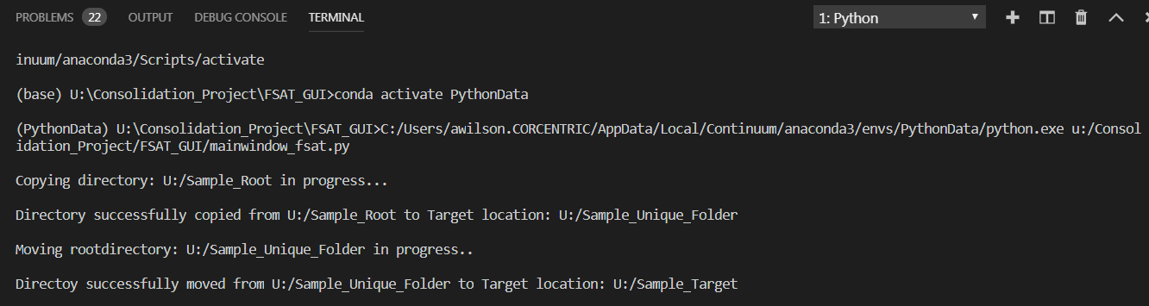

Users will also receive feedback in the File Explorer Application (expect a slight delay in feedback)

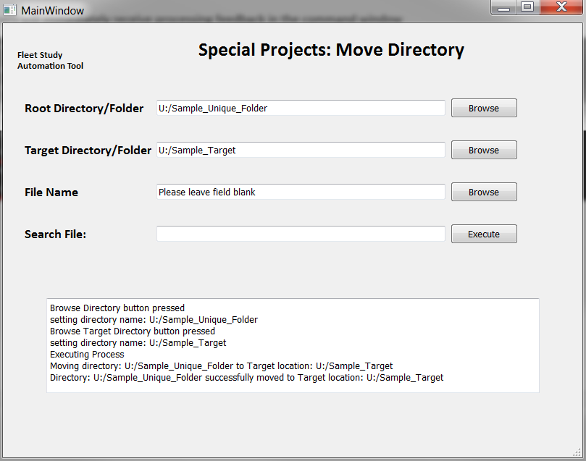

Lastly, open the Target Directory/Folder Location and users will see the directory has been copied successfully. Close window.

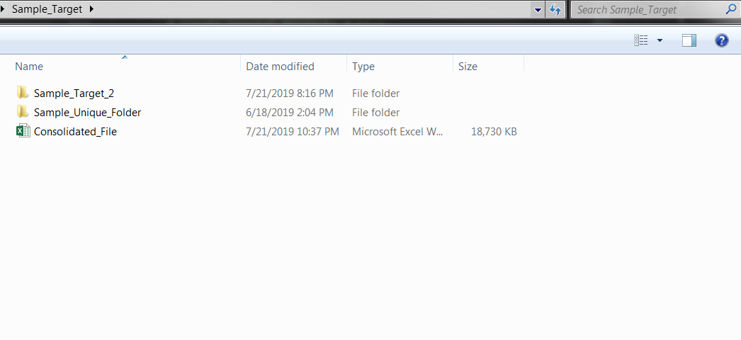

## Step 4c: Find File

The Find File allows users to search an existing directory location for all instances of a file name.

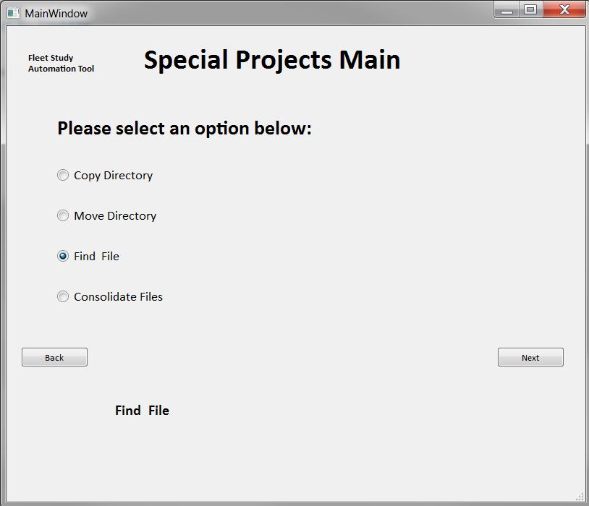

First, pass in the Root Directory to search by clicking the ‘browse’ button or type in the full path.

Next, pass type in file name. Lastly, click ‘Execute’.

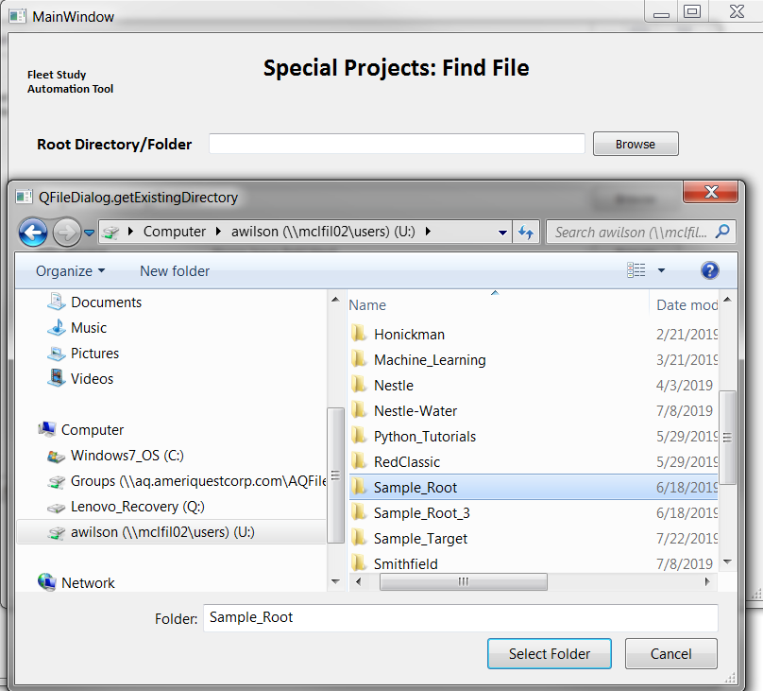

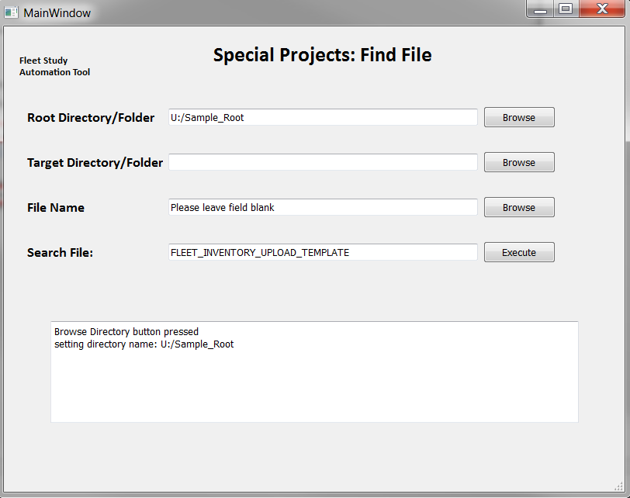

Users will immediately receive processing feedback in the command window

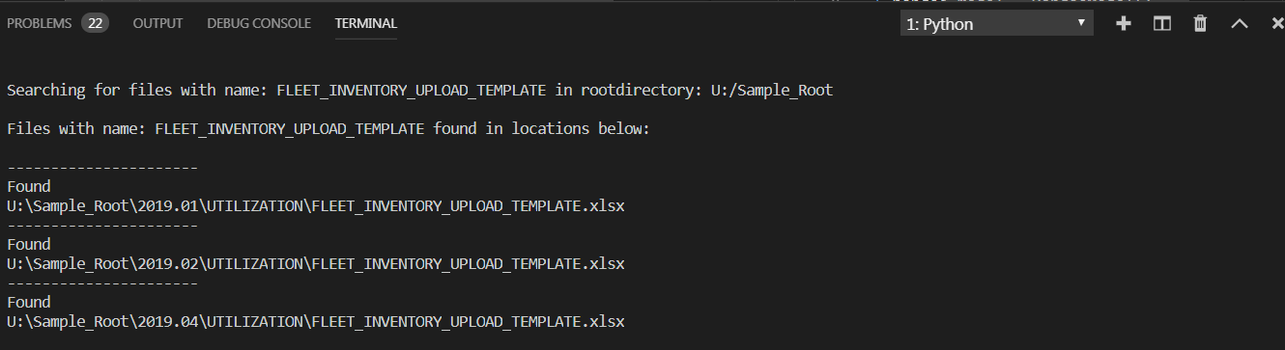

Users will also receive feedback in the File Explorer Application (expect a slight delay in feedback)

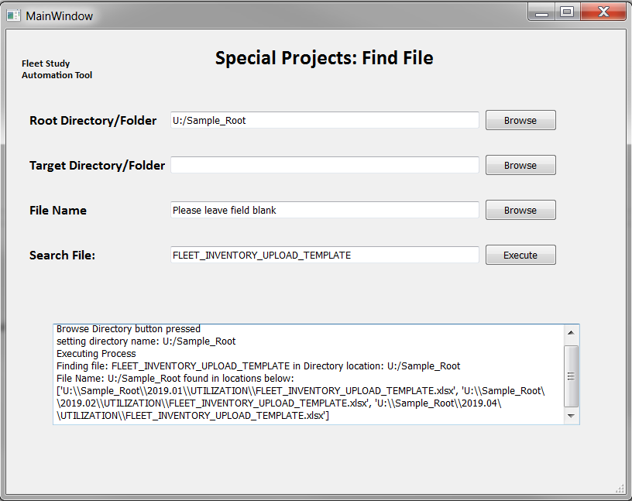

Lastly, there is no output for this process. Once user feedback is received, the process has completed successfully. Close window.

## Step 4d: Consolidate Files

The Consolidate Files allows users to locate all instances of a file name in an existing directory and consolidate all instances of those files into a single file.

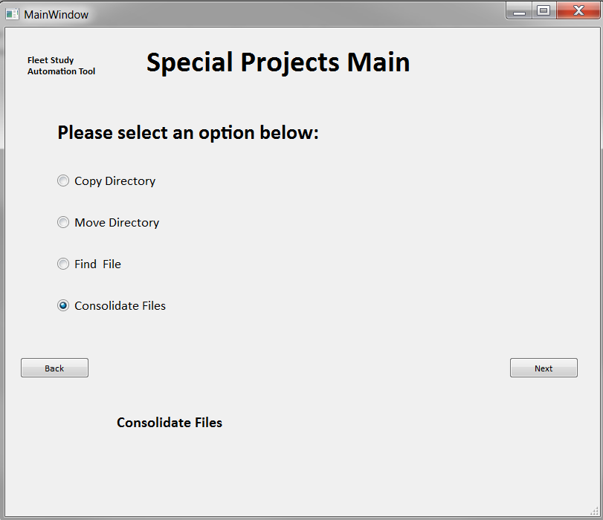

First, pass in the Root Directory to search by clicking the ‘browse’ button or type in the full path.

Next, pass in the Target where consolidated file will output by clicking the ‘browse’ button or type in the full path.

Then, pass type in file name to search. Lastly, click ‘Execute’.

**Note: The process will only consolidate files who share the exact field structure.**

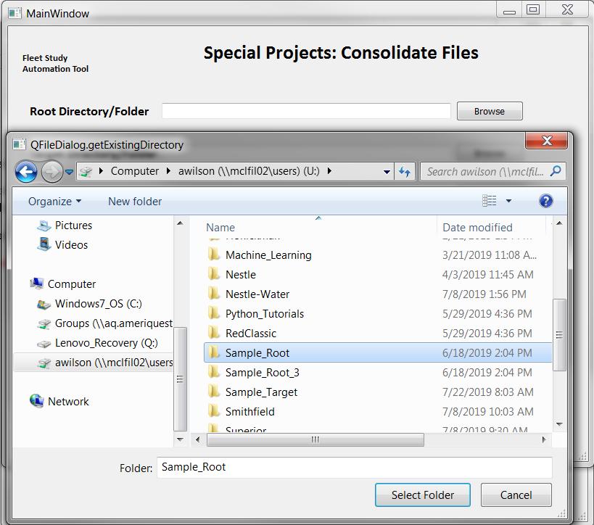

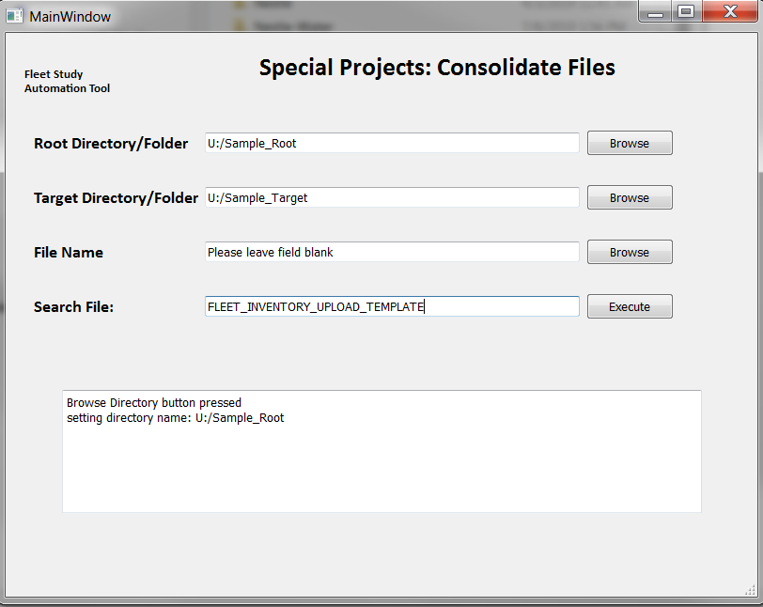

Users will immediately receive processing feedback in the command window. Please be patient as this process may take time.

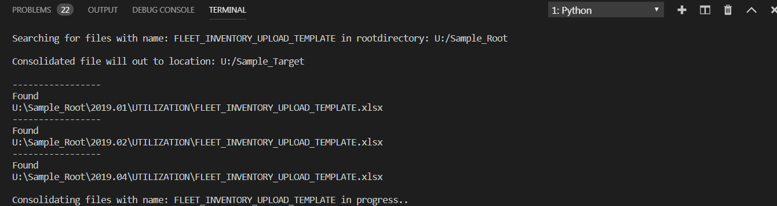

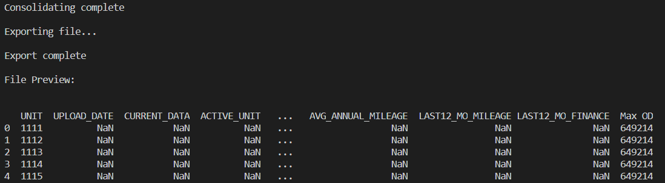

Users will also receive feedback in the File Explorer Application (expect a slight delay in feedback)

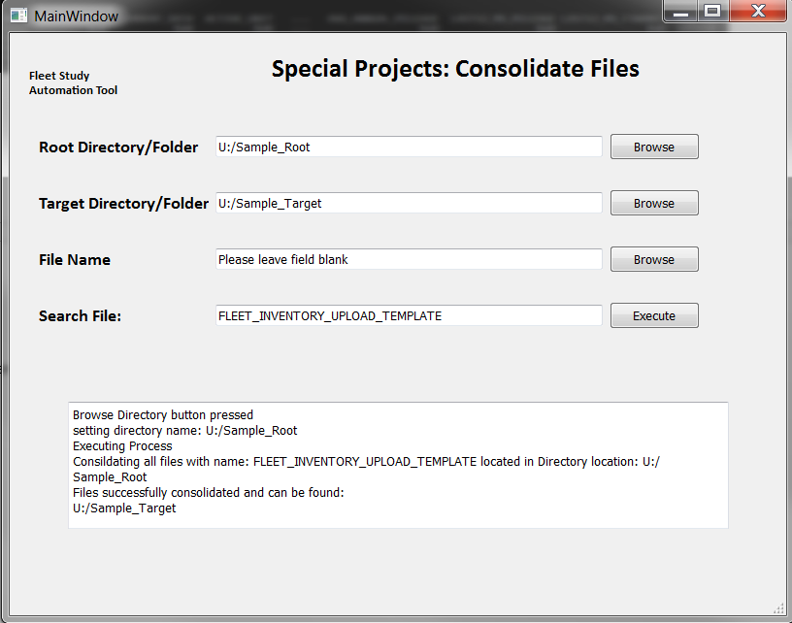

Lastly, open the Target Directory/Folder Location and users will see consolidated file has been created successfully. Close window.

